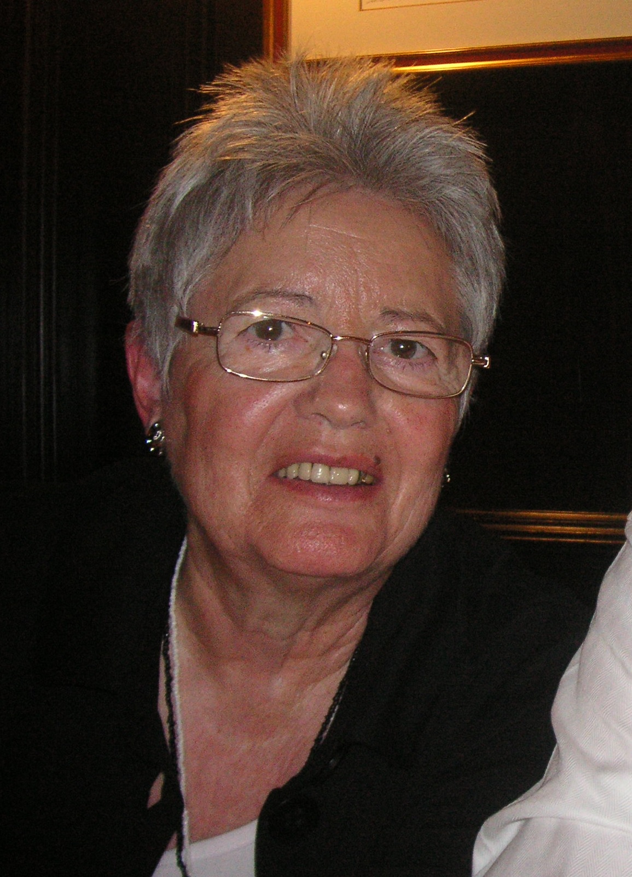

Gertrud Prestele

* 19.08.1936

-

† 06.07.2019

Beloved
Wife
Mother
Grandmother

After a life full of joy, happiness and adventures, Gert passed away on a sunny Saturday morning at home in the presence of her family.

Even though she was diagnosed with Parkinson 20 years ago, Gert never gave up and stayed optimistic. “One hundred years old I will become!”, she always answered when asked about her future thoughts. She kept going on for a long time, only bothering here and there, but still being the kind and cordial person she always was.

Until this incurable disease made life more and more difficult, she did what made her happy – traveling around the world, being a lovely host, cooking delicious meals, telling jokes (most of them about how stupid men are) and stories. A lot of wonderful stories.

Unfortunately her last years were tough. Increasing dementia, losing the ability to walk on her own and finally being unable to communicate properly - life became not only complex for Gert, but also for her family.

In the end death came as release. But it is still a painful loss for her family and me. I will remember her with all my heart and I hope you also have cheerful memories of her to recall.

Karl with family

