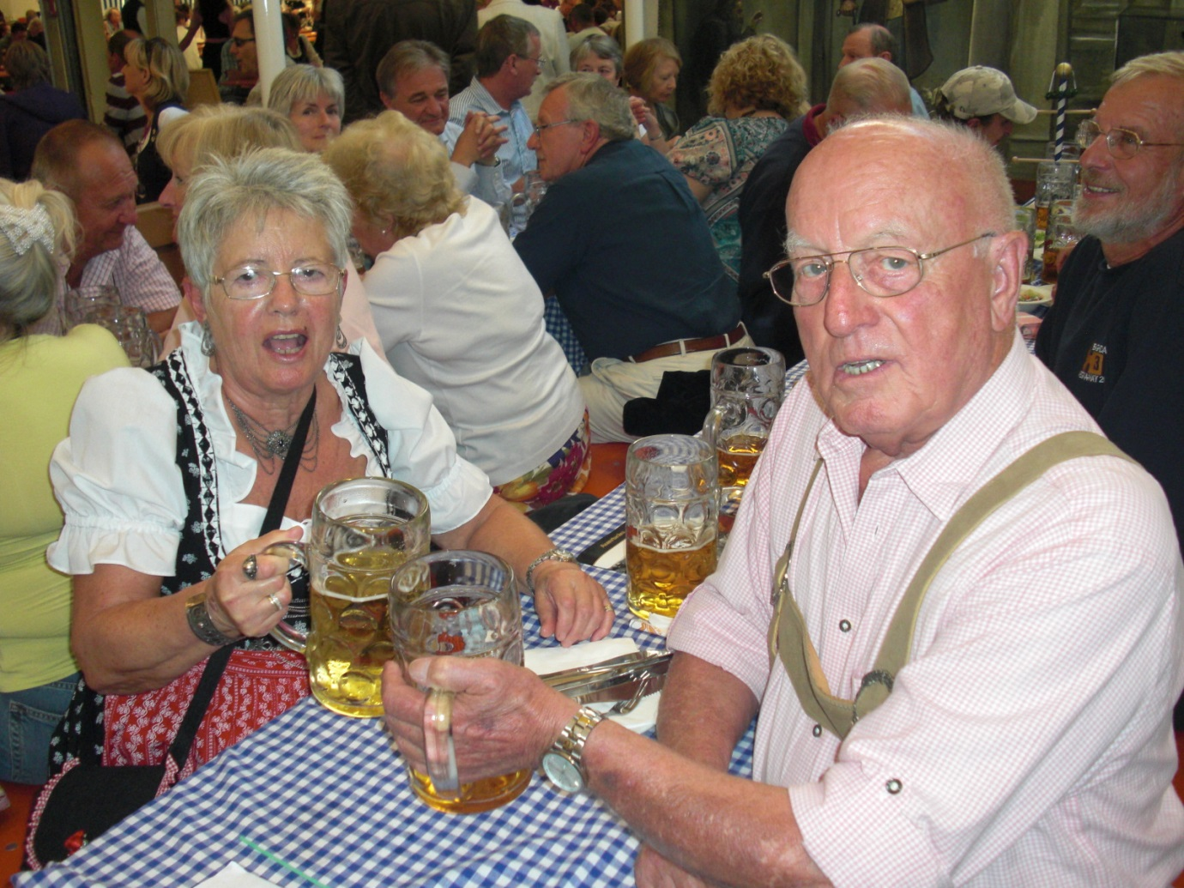
Gert and Karl – doing what Hashers do best!~ Frasdorf 2010
It is with great sadness I have to inform members of the Hash that after a long illness Gert Prestele passed away peacefully at home on 6th July 2019 with Karl as ever present by her bedside together with her family. Gert had battled with Parkinsons and subsequently Dementia over a period of 20 years and fought to the last to say alive. In the beginning her optimism sustained her but her inability to travel and entertain gradually took its toll.
Gert will be remembered for her quiet ready wit and love of fun. I fondly recall at the hash in Nea Makri in 2001 she surprised the several children that were there by telling them she was the “Hash Witch”, then had them festooning the trees in the hotel garden with hand-made decorations for the “Hash party” to be held later.
Gert was also multilingual with an excellent command of the English language. Andy recalls how back in 1984/5 at a function in the newly built university building for which Karl was the project manager, Gert took to the lectern and assisted Karl by giving on his behalf his presentation in English. On the coach back from the Herbfest in Rosenheim in 2010 she entertained those around her with a succession of jokes.
In her final years the inability to walk unaided, together with the increasing dementia that robbed her of the ability to communicate properly, or recognise persons, even her nearest and dearest, was distressing for Gert, and particularly for the family not the least for Karl who was her major carer through all this time.
Rest in Peace Gert, our thoughts are with you and with Karl and the family.

Alan Kennedy aka Honeynuts

