More sad news I am afraid, Jiri Petrak, known as E.G. to most of you, unfortunately passed away Saturday 6th October.
Jiri has been ill for some years now and Prague 2013 was the last reunion he attended, which he Hosted and Hared with Josef his son (pictured).
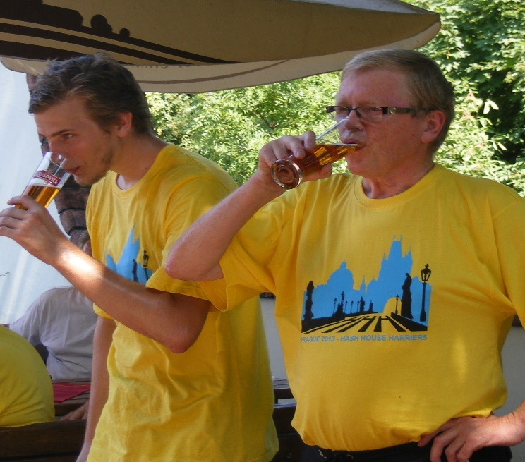
Jiri was managing his illness, apart from being left profoundly deaf by the blood cancer, he could manage that by using an IPhone app that converted speech to text (sometime with hilarious mis-conversions on the apps part). The last visit I made we spent many an hour arguing politics, especially Brexit as he disliked Brussels politics, difficult to argue politics on an IPhone speech/text converter, but he enjoyed it.
Hana says that a few months back he was becoming weaker and it appears the blood cancer was returning, so biological chemotherapy was started but on Saturday evening he complained of feeling tired and his chest hurt. An ambulance was called and arrived fast but Jiri’s heart gave out and he died quickly with Hana present.
Most of you know him from Baghdad but before that he worked in Basra building bridges. He used to go off weekends into the wilds of southern Iraq in his old pickup, just visiting isolated villages and homes with large bags of aspirin for the adults and chocolate for the children. He said you could always get a bed in exchange for those simple barter goods as long as you didn’t mind sharing it with bugs and fleas. He had some marvellous natural photos of Iraqis in their simple homes and lifestyle.
Jiri was a good friend, a very generous and kind-hearted man with a very dry sense of humour. He also made the best Goulash I have ever tasted!
He will be greatly missed. The funeral was on Friday 12th October.
An obituary from a Czech economics/business magazine is shown below.
Rest in Peace Jiri (E.G.) Petrak.

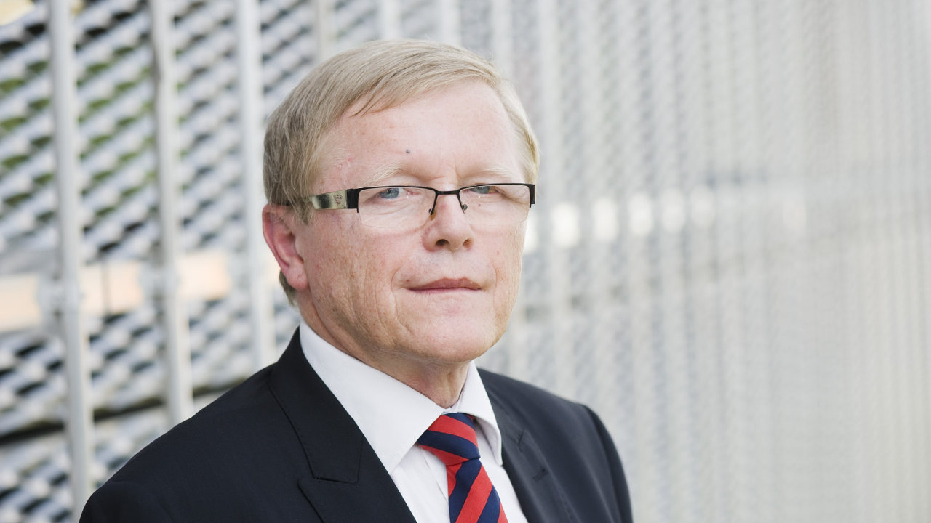

Jiří Petrák, former CEO of the Czech subsidiary Mott MacDonald, as well as co-founder of the Shadow Management Foundation.
author: Jiří Pšenička
On Saturday, October 6, at the age of 71, Jiří Petrák, former CEO of Czech branch of design and consulting firm Mott MacDonald, died after a long illness. HN was told by his wife. Farewell to the deceased will take place on Friday, October 12, at 2 pm at the Strašnice Crematorium in Prague.
Jiří Petrák was a well-known fighter for clearing public procurement of corruption and clientele in the field of traffic engineering. In recent years, for example, he has been very involved in the debate on the D1 motorway reconstruction. He was of the opinion that the modernization of the most important Czech artery, as it is currently underway, is unnecessary, overpriced and serves only the needs of the concrete lobby, not motorists and car transporters.
Previously, he also spoke publicly against the D47 motorway north of Moravia, which he described as poorly designed and unsuccessful in terms of geological exploration and its construction. "The project should not be done at all, and if so in a completely different way and for a third of the money," he said six years ago in an interview with the weekly Ekonom. He also criticized the former government of Milos Zeman, who in 2002 gave the D47 contract to an exclusive Israeli company Housing & Construction.
In recent years, he has strongly advocated that construction companies should provide a state guarantee for work over the entire life of the motorway.
"He was quite exceptional for me, from whom I learned a lot, and he showed personal heroism in the darkest times when Aleš Řebíček was the Minister of transport. He [Jiří Petrák] was the only one who was not afraid to talk publicly about all the abusers, even at the price of being controlled the company was cut off from public contracts”, entrepreneur Radim Jančura, owner of the Brno Transport Student Agency, remembers HN for Jiří Petrák. In 2013, together with Jiří Petrák, they founded the Shadow RDS Foundation, which drew attention to the disruptions in public procurement. Jančura, according to his words, believes that even without Jiří Petrák there are enough people who will not be indifferent to this issue.
Jiří Petrák graduated from the Faculty of Civil Engineering, CTU specializing in bridge construction (1972). After college he worked for 11 years as a designer at the Project Institute of Transport and Civil Engineering (PÚDIS). Since 1983 he was involved in the management of major transport structures in Iraq under international contracts. But politically he did not engage.
He established close contacts with the multinational consultancy, engineering and design company Mott MacDonald. From 1989 to 1991, he worked for them in Great Britain. In 1993, he founded a branch in Prague, headed as an executive until the beginning of 2012 when he retired. Even as a pensioner, he worked in the industry until the insidious disease affected him. He founded XY Develop, as co-owner and business director. He strongly advocated the development of trade relations in the Arabian Peninsula.

